Report _ Neural Networks

Name: Mithunjai. E
Roll number: 24BAD071

Objective
The objective of this project is to implement and compare Simple RNN, LSTM, and GRU neural network architectures for sentiment classification. The models are evaluated using accuracy, precision, recall, F1-score, and training time to understand their classification performance and computational requirements.

1. Dataset and Text Preprocessing
- The sentiment analysis experiment was performed using a binary sentiment classification dataset containing 50,000 text samples. The dataset was divided into 25,000 training samples and 25,000 testing samples.
- The text data was converted into numerical sequences so that it could be processed by neural network models. A vocabulary size of 10,000 was used. Since neural networks require sequences of consistent length within a batch, the input sequences were padded to a maximum length of 200 tokens.
- The resulting training and testing input shapes were (25000, 200). The sentiment labels were represented using binary values corresponding to the two sentiment classes.
- The preprocessing pipeline can be summarized as:
  - Raw Text → Text Preprocessing → Tokenization / Integer Encoding → Padding → Train/Test Data → Neural Network Models

2. Model Architecture
Three recurrent neural network architectures were implemented for sentiment classification: Simple RNN, LSTM, and GRU.
Simple RNN
- The Simple RNN model consists of an Embedding layer, a SimpleRNN layer, a Dropout layer, and a final Dense output layer. The Simple RNN processes the input sequence sequentially while maintaining a hidden state.
LSTM
- The LSTM model uses an Embedding layer followed by an LSTM layer, Dropout layer, and Dense output layer. LSTM networks use gated memory mechanisms to retain or discard information over time.
GRU
- The GRU model consists of an Embedding layer, GRU layer, Dropout layer, and Dense output layer. GRU uses update and reset gates to control information flow while having a simpler structure than LSTM.
- All three models were trained for 5 epochs using the same general preprocessing pipeline so that their performance could be compared.

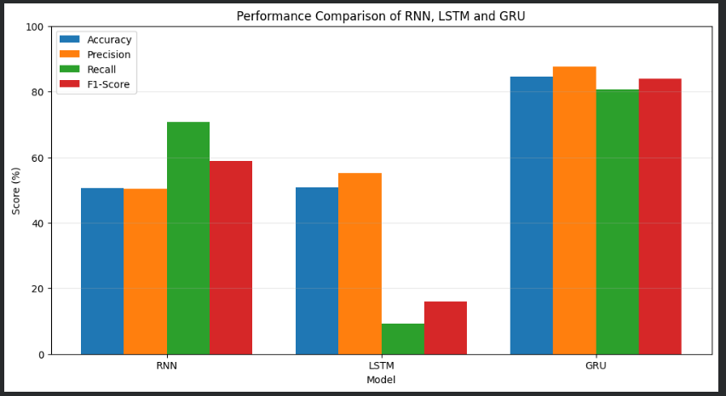

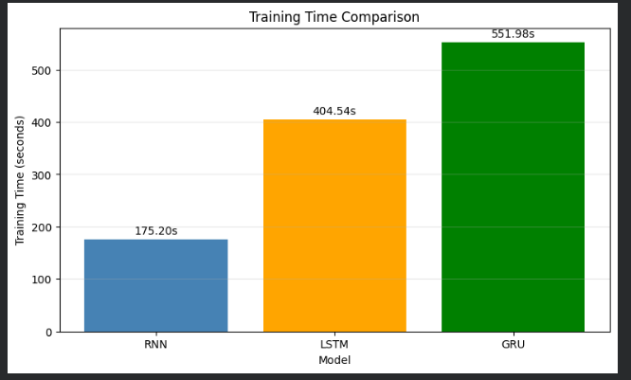

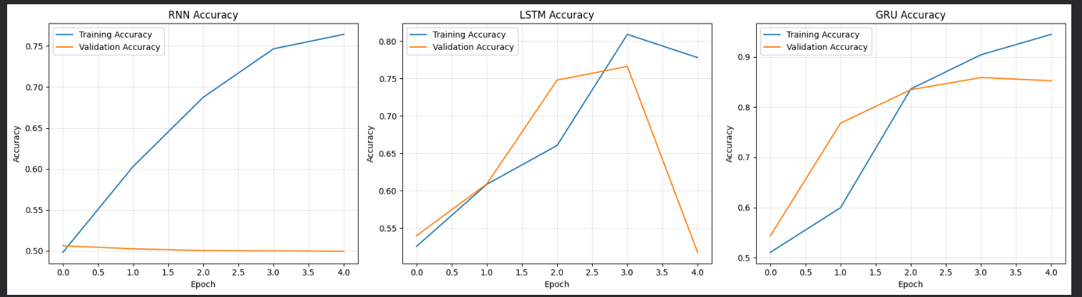

3. Results and Comparative Analysis
- The three models produced noticeably different results on the sentiment classification task.
- The Simple RNN achieved an accuracy of 50.61%, precision of 50.44%, recall of 70.66%, and F1-score of 58.86%. Its training time was 175.20 seconds, making it the fastest model among the three. However, its relatively low accuracy indicates that the model had difficulty learning the sentiment patterns effectively.
- The LSTM model achieved an accuracy of 50.88%, precision of 55.18%, recall of 9.33%, and F1-score of 15.96%. Its training time was 404.54 seconds. Although LSTM is designed to handle long-term dependencies using gated memory, the obtained test results were weak in this experiment. In particular, the low recall resulted in a low F1-score.
- The GRU model achieved the highest test accuracy at 84.63%. It also achieved the highest precision of 87.66%, recall of 80.60%, and F1-score of 83.98%. Its training time was 551.98 seconds, which was the longest among the three models.
- Therefore, based on the measured test-set results, GRU provided the strongest overall classification performance in this experiment. However, it required more training time than both RNN and LSTM.
- The results demonstrate that model architecture can have a significant effect on sentiment classification performance. The gated recurrent structure of GRU was able to capture useful sequential information more effectively for this particular dataset and experimental configuration.
- It is also important to observe the difference between training and validation performance. The final training accuracies were 76.41% for RNN, 77.79% for LSTM, and 94.49% for GRU, while the corresponding final validation accuracies were 49.96%, 51.72%, and 85.26%. The GRU therefore maintained substantially better validation performance than the other two models in this experiment.
4. Conclusion
- This experiment implemented and compared three recurrent neural network architectures, namely Simple RNN, LSTM, and GRU, for binary sentiment analysis.
- The models were evaluated using accuracy, precision, recall, F1-score, and training time. The experimental results showed clear differences between the architectures. RNN required the least training time but achieved relatively low test accuracy. LSTM required more training time than RNN, but its test performance was also relatively low in this experiment.
- GRU achieved an accuracy of 84.63%, precision of 87.66%, recall of 80.60%, and F1-score of 83.98%. These were the highest values among the three models in the obtained test results. However, GRU also required the longest training time at 551.98 seconds.
- Overall, the experiment demonstrates the importance of selecting an appropriate recurrent architecture for sequence classification. For the particular dataset, preprocessing configuration, hyperparameters, and training setup used in this experiment, GRU produced the strongest overall test-set performance.

5. Limitations and Future Work
- The experiment has several limitations. The models were trained for only five epochs, and the results depend on the selected vocabulary size, sequence length, embedding configuration, recurrent-layer configuration, dropout, optimizer, and other hyperparameters.
- The RNN and LSTM models showed a substantial difference between training and validation performance, suggesting that the selected configurations did not generalize as effectively as the GRU configuration. Further experiments could investigate different learning rates, batch sizes, dropout values, recurrent-layer sizes, sequence lengths, and regularization methods.
- Future work could also compare bidirectional RNN, LSTM, and GRU architectures, pretrained word embeddings, attention mechanisms, and transformer-based models. Multiple training runs with different random seeds could also be performed to obtain more robust performance estimates.

Evaluation Metrics
- The models were evaluated using five measures: accuracy, precision, recall, F1-score, and training time.
- Accuracy measures the proportion of correctly classified samples among all test samples.
- Precision measures how many samples predicted as positive were actually positive.
- Recall measures how many actual positive samples were correctly identified by the model.
- F1-score is the harmonic mean of precision and recall and provides a combined measure of both metrics.
- Training time measures the time required to train each model and provides an indication of computational cost.
- Using multiple metrics provides a more complete evaluation than accuracy alone, particularly when precision and recall differ substantially.

